Ex. No: 04
Date: 01/05/2026
Analyze the Malicious Network Traffic using Wireshark
Experiment No. | 04
Experiment Title | Analyze the Malicious Network Traffic using Wireshark
Platform | TryHackMe
Hours Required | 2
TryHackMe Link | https://tryhackme.com/r/room/c2carnage

AIM
To analyze malicious network traffic using Wireshark by investigating a C2 (Command and Control) carnage scenario to identify attacker infrastructure, protocols used, and extracted indicators of compromise.
TOPICS COVERED
- Introduction to Wireshark
- C2 Traffic Analysis
- HTTP Traffic Investigation
- DNS Query Analysis
- TCP Stream Analysis
- Filtering and Pattern Recognition
- IOC Extraction
- Protocol Hierarchy Statistics
- Export Objects from Captures
THEORY
Introduction to Wireshark
Wireshark is a free, open-source network protocol analyzer that allows you to capture and interactively browse network traffic. It is the industry-standard tool for network traffic analysis and troubleshooting.
Key features:
• Deep inspection of hundreds of protocols
• Live capture and offline analysis
• Standard three-pane packet browser
• Powerful display filter engine
• Export objects from captures (HTTP, SMB, etc.)
C2 Traffic Analysis
Command and Control (C2) servers are used by attackers to communicate with compromised machines (bots). Identifying C2 traffic is critical in incident response.
C2 communication often uses:
• HTTP/HTTPS (to blend with normal traffic)
• DNS (DNS tunneling)
• IRC and other protocols
• Custom encrypted protocols
Indicators of C2 traffic:
• Beaconing patterns (regular intervals)
• Connections to unusual domains or IPs
• Large amounts of data being sent out
Wireshark Filters
Display filters are used to narrow down packets of interest.
Useful filters:
• http.request: Shows HTTP requests
• dns: Shows all DNS traffic
• tcp.stream eq [N]: Follow a specific TCP stream
• ip.addr == [IP]: Filter by IP address
• frame contains 'string': Search packet content
• http.request.uri contains 'keyword': Filter URLs
• tcp.flags.syn == 1 && tcp.flags.ack == 0: SYN packets
Protocol Hierarchy Statistics
Statistics > Protocol Hierarchy in Wireshark provides a breakdown of protocols observed in the capture file. This helps identify unusual or unexpected protocols that may indicate malicious activity.
Export Objects: File > Export Objects > HTTP allows you to extract files transferred over HTTP from the capture.
1. Scenario
Task: Investigate the packet capture and uncover the malicious activities.
NOTE: DO NOT directly interact with any domains and IP addresses in this challenge.
Deploy the machine attached to this task; it will be visible in the split-screen view once it is ready.
If you don’t see a virtual machine load, then click the Show Split View button.
Press enter or click to view image in full size
1.1. Read the above.
No answer needed
2. Traffic Analysis

This image and all the theoretical content of the present article is TryHackMe´s property.
Are you ready for the journey?
Please, load the pcap file in your Analysis folder on the Desktop into Wireshark to answer the questions below.
Answer the questions below
2.1. What was the date and time for the first HTTP connection to the malicious IP? (answer format: yyyy-mm-dd hh:mm:ss)
2021-09-24 16:44:38
Configured date and time format.
Clicked Edit > Preferences > Columns > Time > UTC date, as YYYY-MM-DD, and time > OK.
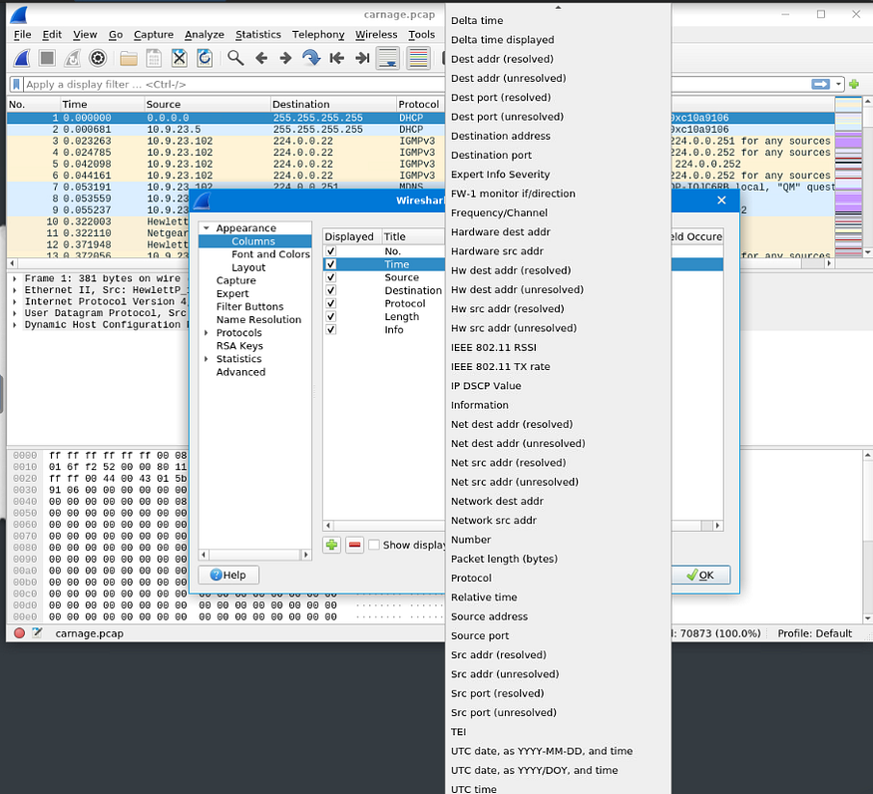

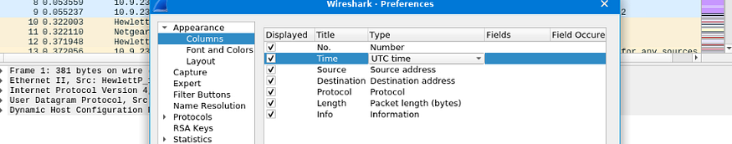
Applied filter http.
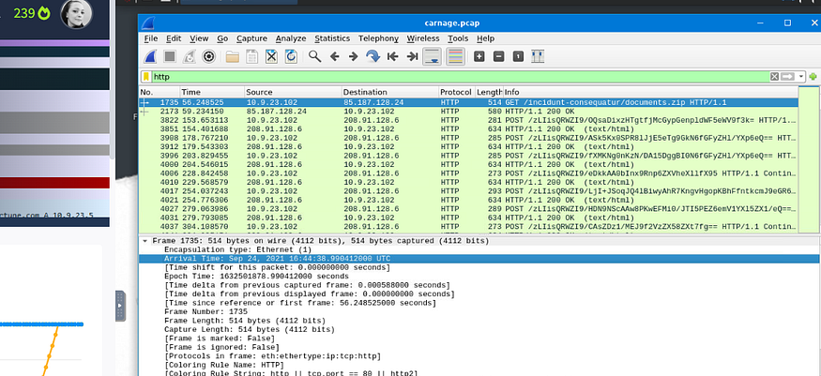
2.2. What is the name of the zip file that was downloaded?
documents.zip
Got the answer in the frame analyzed in 2.1.
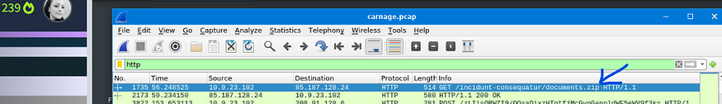
2.3. What was the domain hosting the malicious zip file?
attirenepal.com
Got the answer in the frame analyzed in 2.1: clicked over the frame and then over Hyper Text Transfer Protocol.
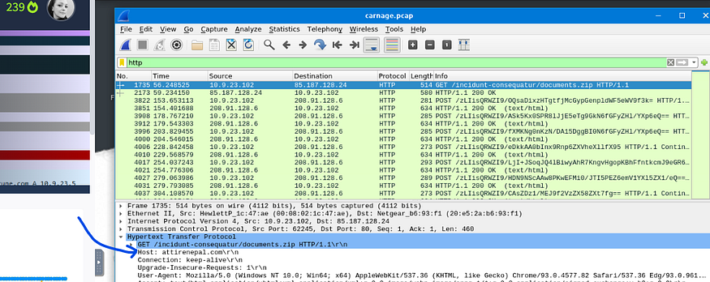
2.4. Without downloading the file, what is the name of the file in the zip file?
chart-1530076591.txt
Got the answer in the frame analyzed in 2.1: right-clicked over the frame, selected Follow, selected TCP Stream.
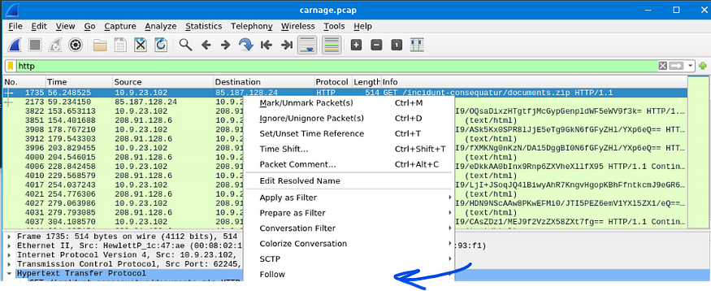
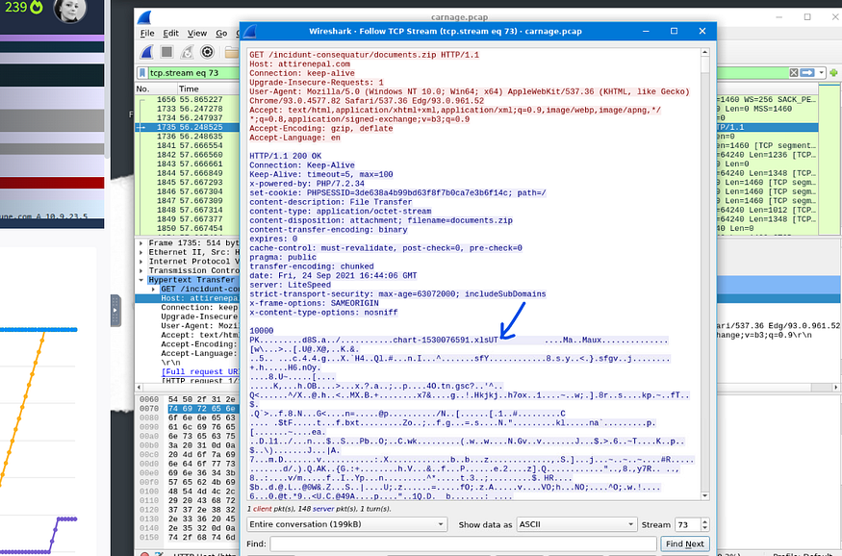
2.5. What is the name of the webserver of the malicious IP from which the zip file was downloaded?
LiteSpeed
Got the answer in the screen we used in 2.4.
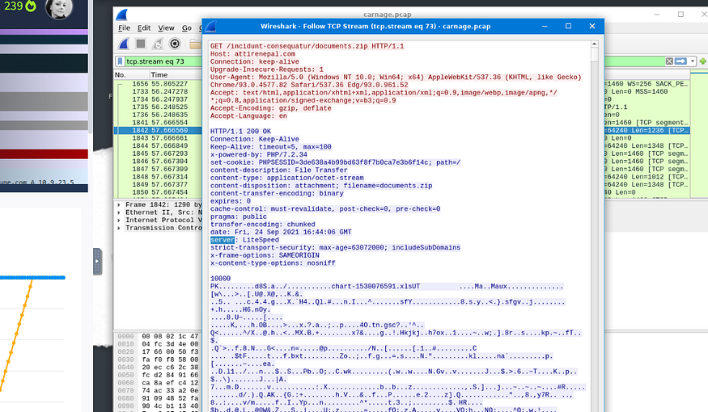
2.6. What is the version of the webserver from the previous question?
1.6. PHP/7.2.34
Got the answer in the screen we used in 2.4.
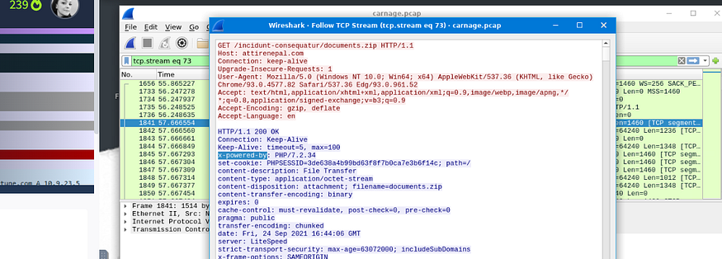
2.7. Malicious files were downloaded to the victim host from multiple domains. What were the three domains involved with this activity?
finejewels.comau,thietbiagt.com, new.americold.com
Cleared the previous filter. Applied dns as display filter.
The room provides a hint: check HTTPS traffic. Narrow down the timeframe from 16:45:11 to 16:45:30.
Updated the filter as shown below
dns&&(frame.time >= “2021–09–24 16:45:11” && frame.time <= “2021–09–24 16:45:30”)
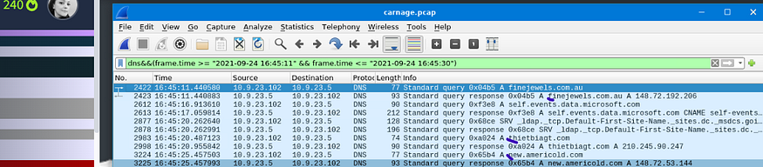
2.8. Which certificate authority issued the SSL certificate to the first domain from the previous question?
GoDaddy
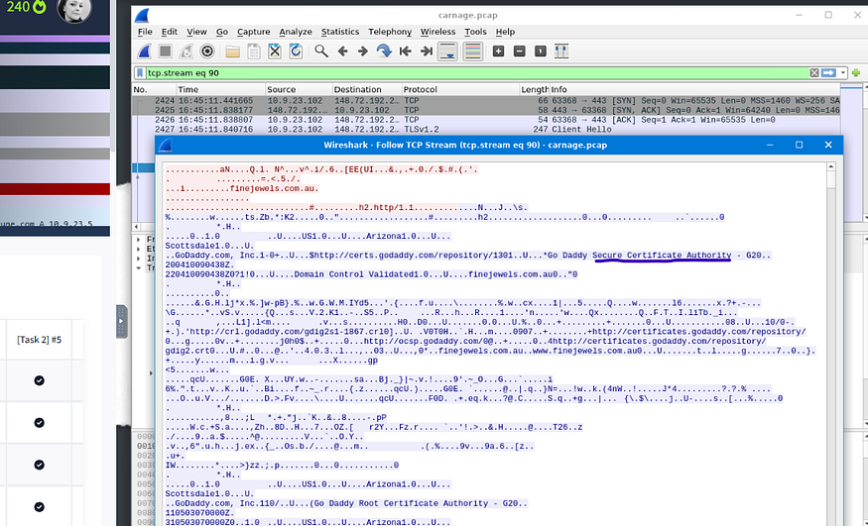
2.9. What are the two IP addresses of the Cobalt Strike servers? Use VirusTotal (the Community tab) to confirm if IPs are identified as Cobalt Strike C2 servers. (answer format: enter the IP addresses in sequential order)
185.106.96.158, 185.125.204.174
In the main menu bar clicked Statistics, then Conversations. Chose TCP. Ordered results by column Packets.
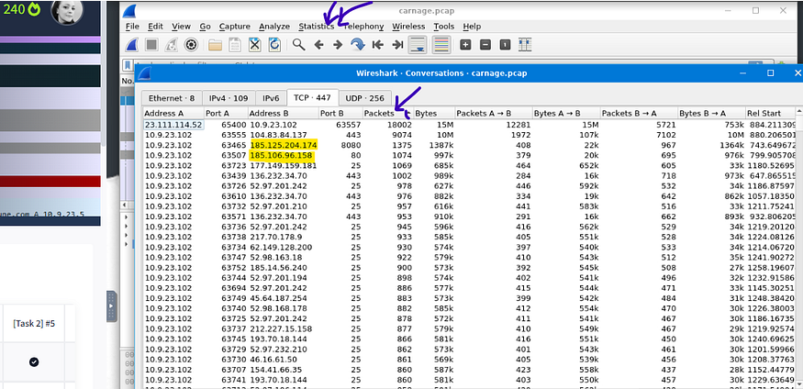
Researched in VirtusTotal and confirmed that it is about Cobalt Strike.
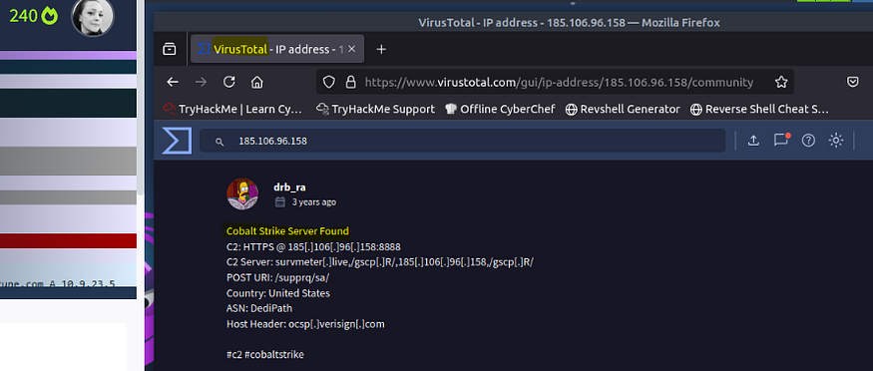
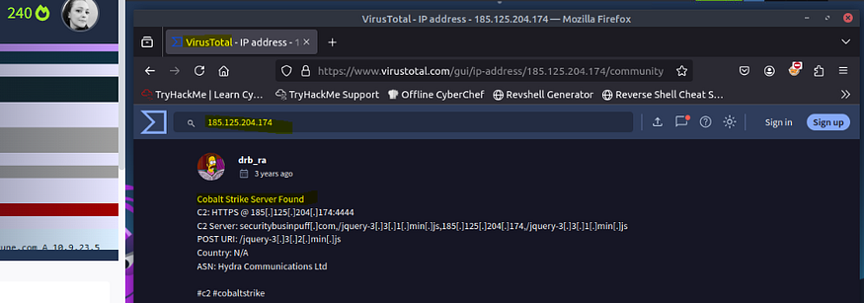
2.10. What is the Host header for the first Cobalt Strike IP address from the previous question?
ocsp.verisign.com
Get RosanaFSS’s stories in your inbox
Join Medium for free to get updates from this writer.
Subscribe
Remember me for faster sign in
Used filter ip.addr == 185.106.96.158
Searched for GET.
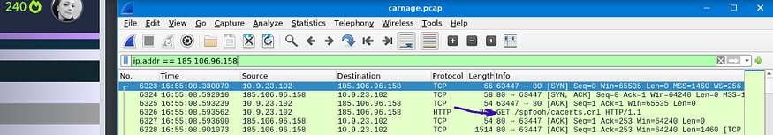
Followed its HTTP Stream.
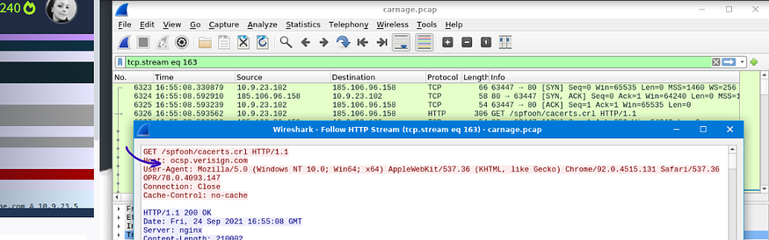
2.11. What is the domain name for the first IP address of the Cobalt Strike server? You may use VirusTotal to confirm if it’s the Cobalt Strike server (check the Community tab).
survmeter.live
It was provided a hint: Filter out for dns queries.
Applied filter: dns.a == 185.106.96.158

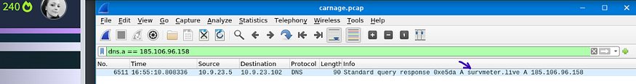
Could also read the information provided in VirtusTotal.

2.12. What is the domain name of the second Cobalt Strike server IP? You may use VirusTotal to confirm if it’s the Cobalt Strike server (check the Community tab).
securitybusinpuff.com
Applied filter: dns.a == 185.125.204.174
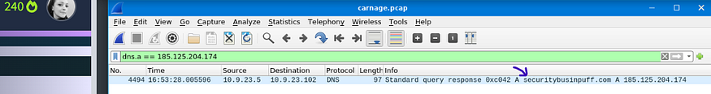
Could also read the information provided in VirtusTotal.

2.13. What is the domain name of the post-infection traffic?
maldivehost.net
It was provided a hint: Filter POST HTTP traffic.
Applied filter: http.request.method = “POST”.
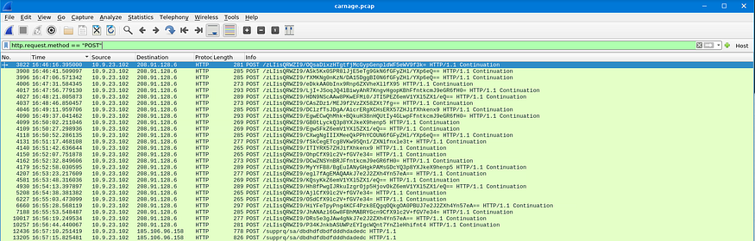
Followed HTTP Stream.
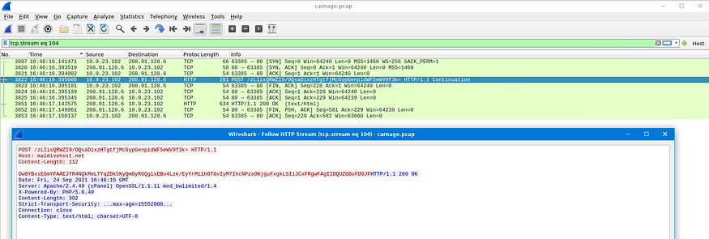
2.14. What are the first eleven characters that the victim host sends out to the malicious domain involved in the post-infection traffic?
LIisQRWZI9
Applied filter: http.host == maldivehost.net.
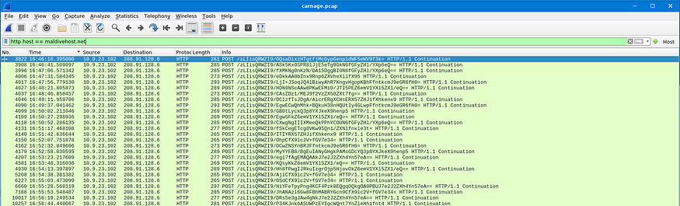
Followed HTTP Stream.
Could have just analyzed HTTP Stream followed in 2.13.
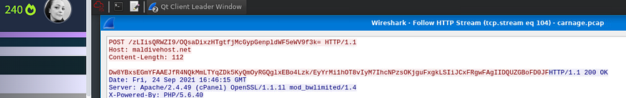
2.15. What was the length for the first packet sent out to the C2 server?
281
Applied filter: http.request.method = “POST”.
Looked for Length field.
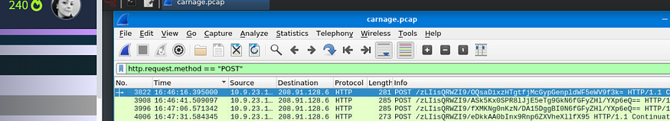
2.16. What was the Server header for the malicious domain from the previous question?
Apache/2.4.49 (cPanel) OpenSSL/1.1.1l mod_bwlimited/1.4
The answer is direct looking into 2.14.
2.17. The malware used an API to check for the IP address of the victim’s machine. What was the date and time when the DNS query for the IP check domain occurred? (answer format: yyyy-mm-dd hh:mm:ss UTC)
Apache/2.4.49 (cPanel) OpenSSL/1.1.1l mod_bwlimited/1.4
Our victim´s machine is 10.9.23.102 .
Applied filter: ip.addr==10.9.23.102 && dns && frame contains “api”
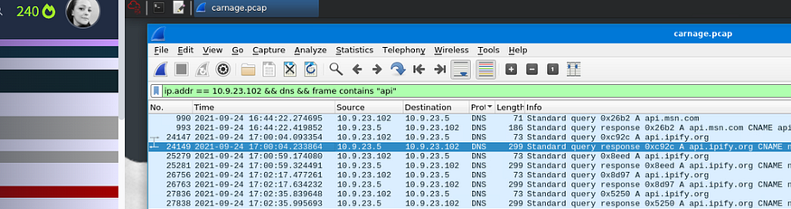
2.18. What was the domain in the DNS query from the previous question?
api.ipify.org
Followed UDP Stream related to 2.17.
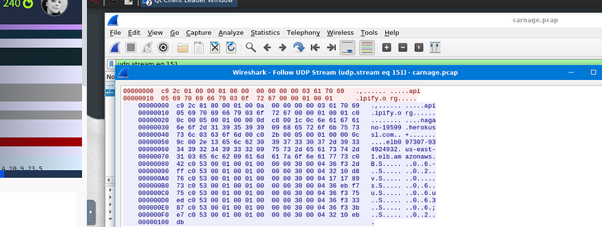
2.19. Looks like there was some malicious spam (malspam) activity going on. What was the first MAIL FROM address observed in the traffic?
farshin@mailfa.com
Applied filter: smtp.req.parameter contains “FROM”
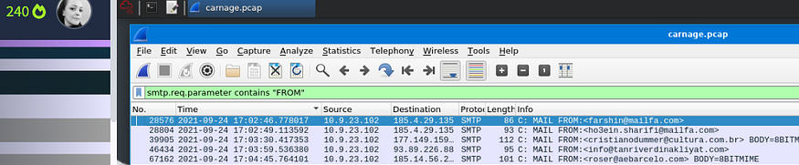
2.20. How many packets were observed for the SMTP traffic?
1439
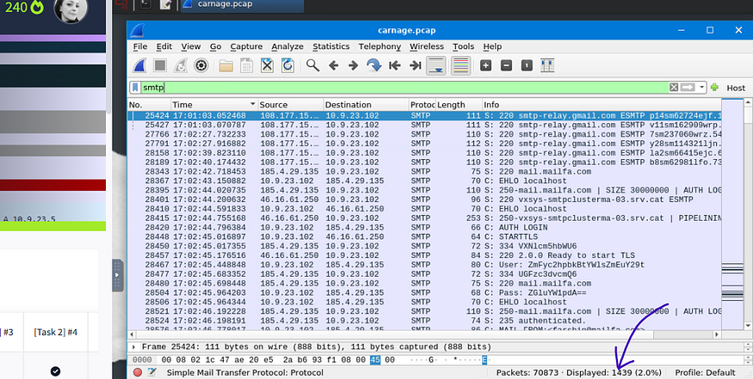
Employed another method to find the answer which was:
— Clicked Statistics in the main menu bar.
— Clicked IPv4 Statistics.
— Clicked IP Protocol Types.
— Typed smtp in Display filter: field.
— Clicked Apply.

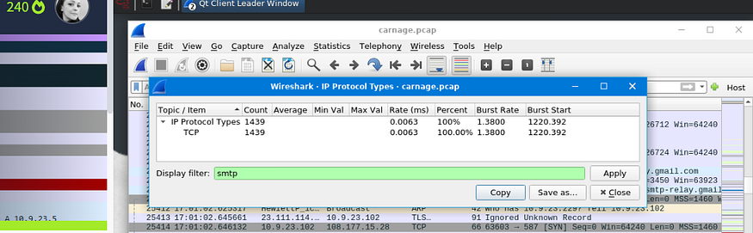

RESULT
Successfully analyzed C2 carnage traffic using Wireshark, identified the malicious C2 server, extracted indicators of compromise including attacker IP addresses, domain names, and communication patterns from the packet capture.

